**Analog Circuitry of PCB**

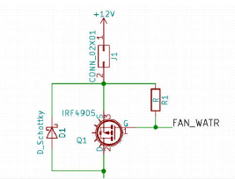**1. Fan-Waterpump Circuitry**

**Components:**

* CONN: Arduino Nano
* R1: Pullup Resistor
* 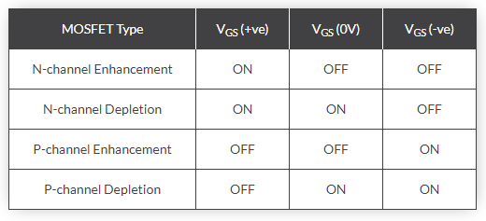IRF4905: P-Channel Enhancement Type Mosfet

**Links:**

* <https://www.electronics-tutorials.ws/transistor/tran_7.html>
* <https://en.wikipedia.org/wiki/Flyback_diode>
* <https://www.allaboutcircuits.com/technical-articles/transient-voltage-suppressors-tvs-an-introduction/>
* <https://en.wikipedia.org/wiki/Zener_diode>
* <https://etechnophiles.com/difference-diode-zener-diode-schottky-diode/>

**Description:**

* **Pullup Resistor:**

This is used to prevent floating of signal (this means that the output is either pulled down or up and down).

In this case since we are using a p-channel enhancement type Mosfet, for it to be normally off, we apply a positive voltage at the gate terminal of the Mosfet so that the signal doesn’t float. For a positive voltage, we used a pullup resistor.

In case we were using a n-channel enhancement type Mosfet we would’ve used a pulldown resistor (resistor connected to ground).

* **IRF4905:**

This Mosfet acts as a switch. When fan water pump signal is actuated from the ECU, a zero voltage is reached at the gate terminal of the MOSFET, because of which Vgs is negative (Vg is zero and Vs is positive 12V), due to which it short circuits Vds (P-Channel Enhancement Type MOSFET) giving the 12V supply it got from the microcontroller to the Main Connector which goes then to the fan and water pump.

* **Schottky Diodes:**

Here fan water pump are inductive loads. So as the circuit is on, they keep on storing charges slowly removing transients received. Then when the circuit goes off all the charges stored in the inductor discharge spontaneously. This damages the circuit.

To prevent this, we use 2 methods:

* + Faster switching to prevent build up of energy or charge in inductor. So, we do faster switching of fan water pump signal given by ECU.
  + Use of Schottky diodes which while in normal condition act reverse bias and while in reverse bias condition (when inductor discharges), acts as a forward bias. Since a Schottky diode has a very low forward potential drop and low recovery time, it is ideal to discharge the diode. This also help protect circuit from back emf.

**2. Fuelpump Circuitry**

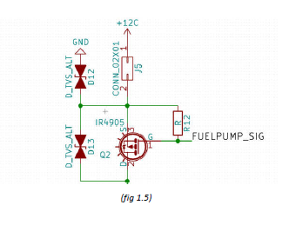

**Components (Except previously explained):**

* **TVS Diode:**

Above bidirectional TVS diodes have been used to reduce especially large amounts of current transients received from the highly inductive circuit of fuel pump and its bidirectional behaviour protects the Mosfet from both directions of overcurrent protection.

Two TVS diodes have been incorporated for the reason that fuel pump spikes are very large and to suppress them its required to use 2 TVS diodes.

**3. ACS712 Current Sensor**

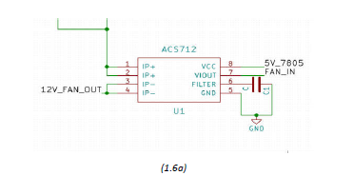

**Links:**

* <https://www.youtube.com/watch?v=650NPqoI7Ag>
* http://henrysbench.capnfatz.com/henrys-bench/arduino-current-measurements/acs712-current-sensor-user-manual/

**Working:**

* At the 1,2 input terminals we get 12V input from the drain of the IRF4905 and the output is taken from the 3,4 terminals of the ACS which go to the connector and then to the respective fan, water pump, fuel pump and ECU.
* At the 8th input pin supply for running of ACS is taken from LM7805 (as it gives less current output).
* 7th pin gives the output signal to the microcontroller which reads the current readings from the current sensor while dynamic testing of car. For storing dynamic data, a SD card module can also be incorporated.
* The 5,6th pin have been used as a filter (Low Pass Filter) to filter out the signals coming to the current sensor so a better clear output is given out to the required component. This value of capacitor is calculated ourselves and resistance for filter is given in data sheet.

**Purpose:**

* We had incorporated the use of ACS for 2 purposes:
  + Primary filtering of signal
  + Measure dynamic current requirements of different components to make required changes of components on PCB or the sensor itself.

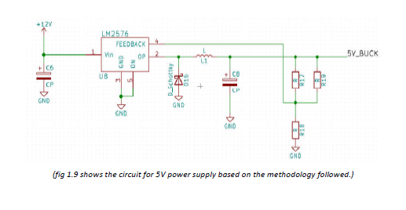**4.Buck Circuit (LM2576)**

**Working:**

* At 1st pin input to buck is taken. Here a decoupling capacitor is used to initially filter out a signal so that the signal is more linear and ripple free.
* 3rd and 5th pins belong to internal circuitry of IC.
* Output is taken from the 2nd pin out. As told earlier the Schottky diode in combination with the decoupling capacitor act as effective tools to filter out the signals and make them clear and smooth. This is also passed through the inductor in series which removes transients and Schottky then helps discharging the inductor.
* This output is then taken across a feedback loop which goes to the 4th terminal of the buck.
* For feedback response R18 above is fixed according to spec sheet of IC and we can vary combination of R17 and R19 for required feedback according to output. E.g. for 5.2V we can set resistance so we get output finally at 5V.